|  |
| --- |
|  |
| NEWSLETTER  September 2021 |
| The Secretary 138 White St. Rangiora 7400 nalgnz@xtra.co.nz |
| **From the President** |

**Rossco Herrett**

Hi Fellow Lefty’s

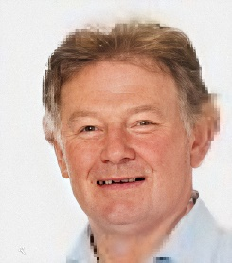I’m writing this message while in lockdown here in Christchurch – hard to believe we are back to here again - when will it end!!!

Winter here in the south has been very inconsistent fine days during the week and rain in the weekend when I want to play golf. Hence my golf has been limited and I can’t wait for spring and renewed enthusiasm to get out on the fairways more regularly.

I’ve spent a fair amount of time watching the Olympics which was such compulsory viewing thank goodness it wasn’t cancelled. What a superb effort by Lydia in winning another medal, she is such a great ambassador for golf and NZ so gracious as a winner and in defeat.

I see several of you lefty’s have been attending tournaments in Mt. Maunganui and Ohope with good attendance at both.

Spring brings us lefty’s an opportunity to play in several local tournaments around NZ and I urge you to participate and bring along a lefty mate and introduce him to the lefty experience. Check out the tournament list in this newsletter.

One such tournament is at Waitikiri on 31st Oct. where there is an opportunity to play the course before the National Tournament in March next year. Preparation for this National tournament is well underway and the entry form along with further information on accommodation is on the nalg website.

Just a shout out to Kerry Smith our life member who has been receiving chemo treatment here in Christchurch over the past weeks. Smithy we wish you all the best and we hope to see you back out on the fairways soon.

Stay safe everyone please get vaccinated and let’s hope we can join other parts of the globe in getting back to some sort of normality.

Take care of yourselves and families and I look forwards to catching up with you around the greens.

Good Golfing

Cheers Rossco.

|  |
| --- |
| Secretaries Blog |

**Rodger Welsh**

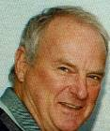

Bookkeeping and attending emails: you have it, every day there is something to be completed or queried: I have to commend all lefties for the feedback and occasionally reminding me of something that requires attention, like our Facebook page.  To arrive at a solution is to suggest; forget the ruling of no cell phones on the golf course (you can turn off the sound) it is the camera and photos essential for recording great if embarrassing moments or that fantastic photo of a golf course or a highlight from elsewhere: Place them on Facebook, don’t be shy.

Well, the long dry certainly turned into something unreal, Golf courses became lakes, rivers or worse. Though some are now playable. Reports coming through from many courses are that earthworm activity and mud is to a real nuisance. The water table is higher than normal and it doesn’t take much to see surface water. You have to take your hat off to the green-keepers and their mates for the way they have coped with the flooding and extended wet. Thank you to the greenkeepers and volunteers.

**Laughter and humour** are distinctly different phenomena though the perception of both is influenced socially. The funniness of a joke can be affected by who tells it and by the cultural origins of the joke. For those who wish to add humour to our pages, accept the fact that a smile denotes success. The president would be most grateful.

**Practical golfing Joke on Jordon Spieth**

**Jordon Spieth and his wife, Annie, were spending time in the Colorado mountains on a short vacation away from the tour. The 12-time PGA Tour winner was looking for an ultra-casual round with some locals. Word began to spread that Spieth was playing the Snowmass Club, a private track just outside Aspen, Colorado. Shane Smith, a local property manager, lives near the 12th green and figured he’d head out to watch the three-time major champion play in his backyard. The 12th hole is a driveable par 4 with an elevated green, so players on the tee cannot see their ball land. Spieth went for the green and pulled it off, sending his drive onto the putting surface, the ball finishing about 20 feet from the hole.**

**Smith, never one to miss an opportunity decided to mark Spaeth’s ball and then immediately placed it in the cup and headed quickly back to his property to watch the proceedings. Spieth on arriving at the green looked everywhere for his ball and finally found it in the hole where he erupted in excitement from achieving his first hole in one on a par 4.**

**At this point Smith yelled out from his property to Spieth spilling the beans where his playing partners and Spieth laughed their heads off before Spieth putted it out for an eagle and they were still heard chuckling when on the next tee.**

**RH**

|  |
| --- |
| Player Profile |

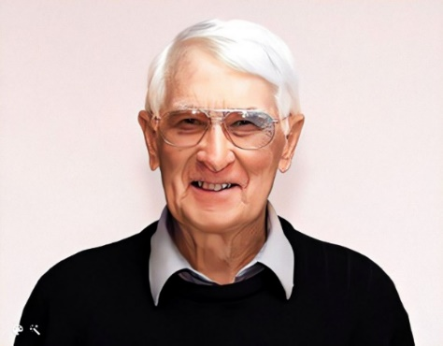

**Grenville "Gren" David Alabaster**

**Born:**10 December 1933 (age 87 years), Invercargill

[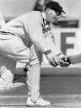](https://www.google.com/search?q=Green+Alabaster&rlz=1C1EJFC_enNZ885NZ885&sxsrf=ALeKk03GEfqDaYn7bWI-fVYidOU-2TvLZw:1628568055956&tbm=isch&source=iu&ictx=1&fir=4ezD4c2XaliEwM%252CMA6d4aCgBTQJeM%252C%252Fm%252F02qdmvj&vet=1&usg=AI4_-kQhChYGjIVC9o0pULG6PJqZYG-47Q&sa=X&ved=2ahUKEwiawN7jyKXyAhVcwjgGHT6PBfYQ_B16BAgxEAI&cshid=1628568145145291#imgrc=4ezD4c2XaliEwM)[**Last**](https://www.google.com/search?rlz=1C1EJFC_enNZ885NZ885&sxsrf=ALeKk03GEfqDaYn7bWI-fVYidOU-2TvLZw:1628568055956&q=gren+alabaster+last+test&stick=H4sIAAAAAAAAAOPgE-LSz9U3MCpMyS3L0pLPKLfST87PyUlNLsnMz9MvSM0vyEm1ykksLlEoSS0uWcQqkV6UmqeQmJOYBBRLLVKASwEATCMXMUoAAAA&sa=X&ved=2ahUKEwiawN7jyKXyAhVcwjgGHT6PBfYQ6BMoADAaegQILBAC&cshid=1628568145145291) **1st class game:**1976[](https://www.google.com/search?q=Green+Alabaster&rlz=1C1EJFC_enNZ885NZ885&sxsrf=ALeKk03GEfqDaYn7bWI-fVYidOU-2TvLZw:1628568055956&tbm=isch&source=iu&ictx=1&fir=4ezD4c2XaliEwM%252CMA6d4aCgBTQJeM%252C%252Fm%252F02qdmvj&vet=1&usg=AI4_-kQhChYGjIVC9o0pULG6PJqZYG-47Q&sa=X&ved=2ahUKEwiawN7jyKXyAhVcwjgGHT6PBfYQ_B16BAgxEAI&cshid=1628568145145291#imgrc=4ezD4c2XaliEwM)

[**Siblings**](https://www.google.com/search?rlz=1C1EJFC_enNZ885NZ885&sxsrf=ALeKk03GEfqDaYn7bWI-fVYidOU-2TvLZw:1628568055956&q=gren+alabaster+siblings&stick=H4sIAAAAAAAAAOPgE-LSz9U3MCpMyS3L0pLMTrbSL0jNL8hJBVJFxfl5VsWZSTmZeemLWMXTi1LzFBJzEpMSi0tSixSgEsUAHW0IC0MAAAA&sa=X&ved=2ahUKEwiawN7jyKXyAhVcwjgGHT6PBfYQ6BMoADAbegQIKhAC&cshid=1628568145145291)**:**[Jack,](https://www.google.com/search?rlz=1C1EJFC_enNZ885NZ885&sxsrf=ALeKk03GEfqDaYn7bWI-fVYidOU-2TvLZw:1628568055956&q=Jack+Alabaster&stick=H4sIAAAAAAAAAOPgE-LSz9U3MCpMyS3LUuIEsS2Nc5JNtSSzk630C1LzC3JSgVRRcX6eVXFmUk5mXvoiVj6vxORsBcecxKTE4pLUoh2sjAA-HM7dSAAAAA&sa=X&ved=2ahUKEwiawN7jyKXyAhVcwjgGHT6PBfYQmxMoATAbegQIKhAD&cshid=1628568145145291) Derek and Molly

**"Gren"** is a former New Zealand first-class cricketer for Otago, Canterbury and Northern Districts. A winner of the New Zealand Cricket Almanack Player of the Year Award in 1972, he was a right-arm off-break bowler. He represented New Zealand on occasions, including the tour to Australia in 1973–74, but never in a Test match. His brother Jack played 21 Tests. He became a New Zealand selector in the late 1980s and managed the New Zealand team on tours of Sri Lanka and Australia in 1987, and again in the 1990s.

Gren took 8/30 for Northern Districts against New Zealand Under-23s in March 1963. This established a new record for the side in first-class cricket, beating Don Clarke's 8/37 of just two months previously. his mark stood for less than a year until Maurice Langdon claimed 8/21 against Auckland in January 1964.  He achieved a hat trick against Canterbury for Northern Districts and also for many years had the best bowling average in 1st class cricket for Northern Districts for those who had 25 wickets or more (18.0) very closely challenged by Don Baird and Don Clarke.   Gren can't ascertain, despite his efforts, whether that has been superseded by somebody else, but it was certainly in Daniel Vettori's book “Turning Point” published in 2008.

In a first-class career stretching from 1955–56 to 1975–76, he took 275 wickets at 23.24, and made 3200 runs at 23.88, with three centuries including the highest score of 108 for Otago against Central Districts at Wanganui in 1964–65. His most successful season with the ball was 1974–75; despite turning 41 during the season, he took 34 wickets at 20.11 and helped Otago to victory in the Plunket Shield.

Gren also played 31 matches for Southland and Thames Valley in the Hawke Cup between 1961 and 1979. He captained Southland during their reign as title-holders between 1973 and 1977. When a Hawke Cup “team of the century” was selected to mark the centenary of the competition in 2011, he was named as the captain.

He became a New Zealand selector in the late 1980s and managed the New Zealand team on tours of Sri Lanka and Australia in 1987, and again in the 1990s.

Gren gained his Diploma of Physical Education at Otago in 1956. He had a long and successful career at Southland Boys’ High School becoming Head of Physical Education and establishing a school-wide adventure camping scheme that replaced cadet training. He earned great respect as a fine teacher and mentor before becoming Deputy Principal at Aparima College, closing his teaching career as Principal at Waiau College for 8 years.

An outstanding sportsman, Gren played basketball for Otago, Canterbury, Southland, and the South Island, gaining Otago and New Zealand Universities Blues, and representing New Zealand in 1954.

In cricket, however, Gren really made his mark. He represented Otago, Canterbury and Northern Districts, captaining New Zealand Universities, Otago to win the Plunket Shield twice, and The Rest to beat New Zealand. He was Bowler of the Year in 1972, scored the fastest century in New Zealand 1st class cricket in 1971, won the Windsor Cup for bowling in 1975, and toured Australia with the New Zealand team in 1973. He selected and coached New Zealand in 1987-88, managing the team in 1995-96.

Gren was named in Otago's Best XI over 135 years and captain of the New Zealand Districts Team of the Century.

Gren is also an ardent player of golf. Historic records will show that at aged 68 he was on a 2 handicap at Alexandra Golf Club he has been on single figures for many years. Gren and Robyn moved to Oxford in 2004 and joined the Waimakariri Gorge Golf Club then in 2012 moved to Tauranga and now plays the Omokoroa Course. From his time at the Waimak to this day, he has played to or under his age on 112 occasions. It is only in the last couple of years that his handicap entered double figures.

Gren has been a valued member of the Left-Handers Association for many years. He assisted in running the Lefty Tournament at the Waimak where he was one of 45 lefty members of the Club!  he resigned from the NALGNZ this year at aged 88. He leaves the Association with great memories and grand times with many comrades who respected him for his remarkable golfing skills and sporting history.

He is also remembered by Ross Herrett and Baz Paton (both good Southland stock) these guys played in an opposing basketball team to Gren though the same Southland team.

To Gren, thank you, a great history. I’m sure there is much more to your legacy. Perhaps one day a sport journalist may take up pen and paper and script your family’s classical sporting adventures.

Rodger Welsh

**Ode to the Golf Ball**

In my hand I hold a ball, white and dimpled, rather small.

Oh, how bland it does appear, this harmless looking little sphere.

By its size I could not guess, the awesome strength it does possess.

But since I fell beneath its spell, I've wandered through the fires of hell.

My life has not been quite the same, since I chose to play this stupid game.

It rules my mind for hours on end, a fortune it has made me spend.

It has made me yell, curse and cry, I hate myself and want to die.

It promises a thing called par, if I can hit it straight and far.

To master such a tiny ball, should not be very hard at all.

But my desires the ball refuses, and does exactly as it chooses.

It hooks and slices, dribbles and dies, and even disappears before my eyes.

Often it will have a whim, to hit a tree or take a swim

With miles of grass on which to land, finds a tiny patch of sand.

Then has me offering up my soul, if only it would find the hole.

It's made me whimper like a pup, and swear that I will give it up.

And

Take to drink to ease my sorrow, but the ball knows ... I'll be back tomorrow

RH

Results from around the regions

**Ohope Golf Tournament** *Lee-Anne Clark & Toni O’Sullivan*

There were 36 lefties in the field and yes Andrea Gardner did play.

 Net Winner: Duncan Rutherford (Te Puke)

Gross Winner: Ken Shea (Te Aroha)

Stableford: Tony Stowers (Te Aroha) 69

 Ladies:

Stableford Winner - Audrey Messenger

Runner Up: Robyn Aitken - Paraparaumu Beach

**Western BOP Lefties Golf** Ray Horsfall

Played in perfect weather (fine and calm) both Fairview and Mount Maunganui Golf courses provided good challenges, and an experience, to all golfers.Very wet weather in the weeks leading up to the tournaments saw Fairview, in particular, with very soft fairways. Both courses presented greens in very good condition.

Great to have 10 new lefties play the 2 days, displaying their talents in winning prizes.

**Fairview Golf Course: Saturday 3rd July 2021.**

**“SPONSORS” “Golf 360 *(Scott Picket)* & Eves Real Estate *(Daniel Dickison)***

32 players, 3 being women, contested day 1, Only 3 players scored better than handicap, the remaining 29 players struggled to reach a score of 34 points.

New to lefties, Duncan Rutherford (Te Puke) scored 40 points to lead ***Division “1”*** by 6 points and with Wayne Hughes and Glen Edwards leading ***Division “2”*** with 37 points.

*And then there were the rest.*

Matty Brown (Mount Maunganui) showed his skill as a greenkeeper scoring the only “2” to take away 2 dozen golf balls.

3 women took part with Sally Roundhill (Rightee) leading with 28 points and the other 2 tied on 26 points.

**Mount Maunganui Sunday 4th July 2021.**

**“SPONSORS” Mount Maunganui Golf Club**

**Golf 360 (Scott Pickett) & Eves Real Estate (Daniel Dickison)**

31 men and 3 women players contested day 2 and only 3 players equal or better than handicap.

**Men’s *Division “1”*** - Won by Tony Stowers (Te Aroha) with 36 points on countback from David Williams (Mount Maunganui). 34 points by Keary Adeane (Ngaruawahia) and George Rogan (Riverside) followed.

**Men’s *Division “2”*** winning stableford of 37 was scored by, new to lefties, Matt Brown (Mount Maunganui) who also won the “ACE” (Allan Elliott Trophy) *– A little* *course knowledge ?.*

35 points was next best by Ray Horsfall (Mount Maunganui) and 34 by Wetini Mokomoko (Ohope), *the 2020 “Ace” trophy winner*, on count-backs from Robin Kent (Hauraki) and Wayne Hughes (Napier).

Previous Trophy winners - David Williams, Wetini Mokomoko and George Rogan all contested hotly to win back the “ACE” trophy.

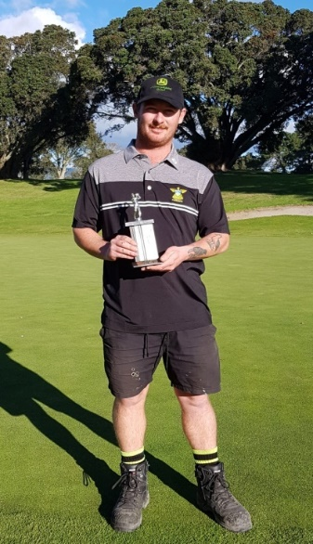We welcomed our first plus handicapper to play our weekend, Kahu Tataurangi (Remuera) scoring a 73 gross

**“ACE” (Allan Elliott)**

**Trophy Winner.**

**Matt Brown** (Greens Keeper)

**Mount Maunganui Golf Club.**



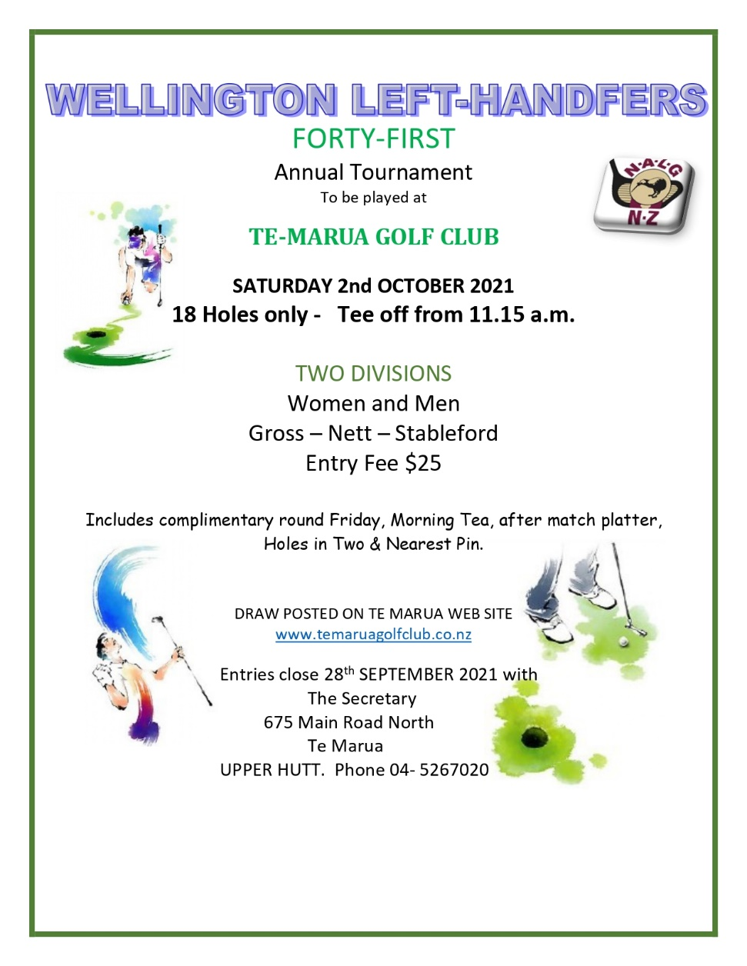

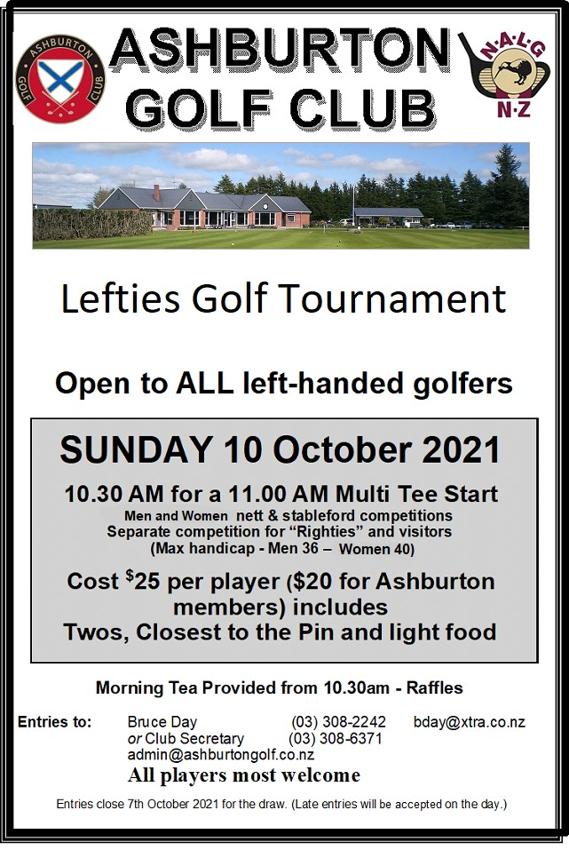







**Tournaments Pending**

These tournaments are yet to be confirmed:

Mangawhai Hauraki

Ngaruawahia Te Aroha Masterton

**SERIOUS LOCK DOWN ADVICE**

Everyone PLEASE be careful because people are going crazy from being locked down at home!

I was just talking about this with the microwave and the toaster while drinking my Pepsi, and we all agreed that things are getting bad.

I didn't mention any of this to the washing machine, because she puts a different spin on EVERYTHING!! Certainly, couldn't share with the fridge, because he's been acting cold and distant! In the end, the iron straightened me out! She said the situation isn't all that pressing and all the wrinkles will soon get ironed out!

The vacuum, however, was very unsympathetic... told me to just suck it up! But the fan was VERY optimistic and gave me hope that it will all blow over soon!

The toilet looked a bit flushed but didn't say anything when I asked its opinion, but the front door said I was becoming unhinged and the doorknob told me to get a grip!! You can just about guess what the curtains told me: they told me to "pull myself together!"

We will survive!!

Pass it on - gotta keep the humour! RH

**Garrick Higgo**

Watch out for this lefty who has emerged as the future take over the mantle of both our Lefty legends Phil Mickelson and Bubba Watson who have held this honour since our Sir Bob retired from the PGA tour.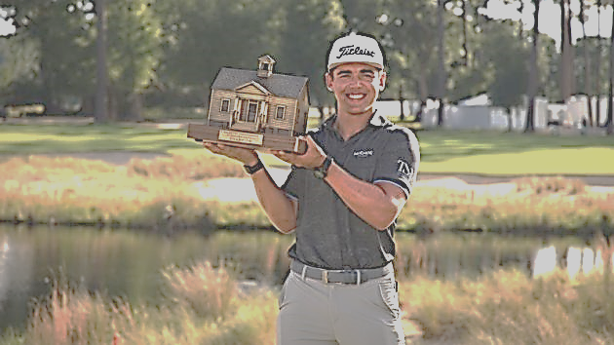

Garrick Higgo Wins First PGA Tour Title at the Palmetto Championship

Higgo clinched a one-shot victory at the Palmetto Championship and win for the first time on the PGA Tour in just his second start.

Amazingly, the 22-year-old South African has now won three times in his last five starts, having tasted success at the European Tour’s Gran Canari, Open and Canary Islands Championship.

Higgo turned professional in 2019 and he has won three tournaments on the European Tour before being invited to play on the PGA tour winning on his 2nd start. He is the first player to win in his first or second start on the PGA Tour since 1988.

To win Higgo entered the final round of the Palmetto Championship trailing by six strokes the largest 54-hole deficit overcome by a winner on the PGA Tour since Bubba Watson won at the 2018 Travelers Championship.

That run of form also earned the left-hander a spot in his first major at this year’s PGA Championship where he made the cut and finished in a highly respectable tie for 64th.

And this latest achievement further highlights the future superstar credentials of the man from Johannesburg who has made a meteoric rise through the ranks we Leftys will be following this man with interest!!!!  RH

|  |  |  |  |  |  |  |
| --- | --- | --- | --- | --- | --- | --- |
| NALGNZ Office Holders  Your 2020 REGIONAL COUNCILLORS | | | | | | |
| President | | | | National  Secretary/ treasurer | | |
| Ross Herrett  66 Fairway Drive  Shirley, Christchurch 8061  [ross.herrett@ccc.govt.nz](mailto:ross.herrett@ccc.govt.nz) | | | | Rodger Welsh  138 White St  Rangiora 7400  [nalgnz@xtra.co.nz](mailto:rodger.welsh@xtra.co.nz)  ph. O21676128 | | |
| South Island | | | | | | | | |
| Tasman | | Aorangi / Canterbury | | | | Otago / Southland | | |
|  | |  | | | |  | | |
| Vacant –  Your name here?  Nominations are being  called for;  Do you know a likely candidate? | | Ross Herrett  66 Fairway Drive  Westhaven  Christchurch 8061  Phone 027 228 4573  [ross.herrett@ccc.govt.nz](mailto:ross.herrett@ccc.govt.nz) | | | | Barry Patton  363 Peninsula Road  Kelvin Heights  Queenstown  Phone: 021 2222 056  [barrypatton4@gmail.com](mailto:barrypatton4@gmail.com) | | |
| Manawatu / Wanganui | | | Hawkes Bay East Coast | | | | Wellington | |
| Tim Belcher  Vice President  40 Caroline Drive  Fielding 4702  ph. 0275652846  [timgbelcher@gml.com](mailto:timgbelcher@gml.com) | | | Wayne Hughes  6 Panapa Road  R D 2 Hastings 4172  Private ph. 06 876 535  [sw.hughes@xtra.co.nz](mailto:sw.hughes@xtra.co.nz) | | | | Bill Werry  Villa 3  20 Race Course Road  Trentham 5018  Ph.04 97701260  [bill@werry.co.nz](mailto:bill@werry.co.nz) | |
| North Island | | | | | | | | |
| Northland / Auckland | | | | Waikato / Bay of Plenty | | Taranaki | | |
| Nuddy Pillay  [nuddy.pillay@xtra.co.nz](mailto:nuddy.pillay@xtra.co.nz)  Murray Horsnell  [backspin88@hotmail.com](mailto:backspin88@hotmail.com) | | | | Wayne Chesham  26 Marnane Tce  Saint Andrews  Hamilton 3200  ph. 0798268  [wayne@attichomes.co.nz](mailto:wayne@attichomes.co.nz) | | Roger Maxwell  P O Box 41  Urenui 4349  ph.067523622  [maxwellrfh@xtra.co.nz](mailto:maxwellrfh@xtra.co.nz) | | |



**For Sale:**

Ray Myers (Templeton Club) email [ray.dragondeath@gmail.com](mailto:ray.dragondeath@gmail.com)

Callaway Mavrik hybrid 4, 6 months old hardly used I can’t master it, regular shaft $350 ONO

Flash Face S220