**Houston Motors 41st**





**Left Handers open Golf Championships**

**Motueka Golf Club**

Saturday March 7th tee off 1pm

&

Sunday 8th March tee off 8.30am

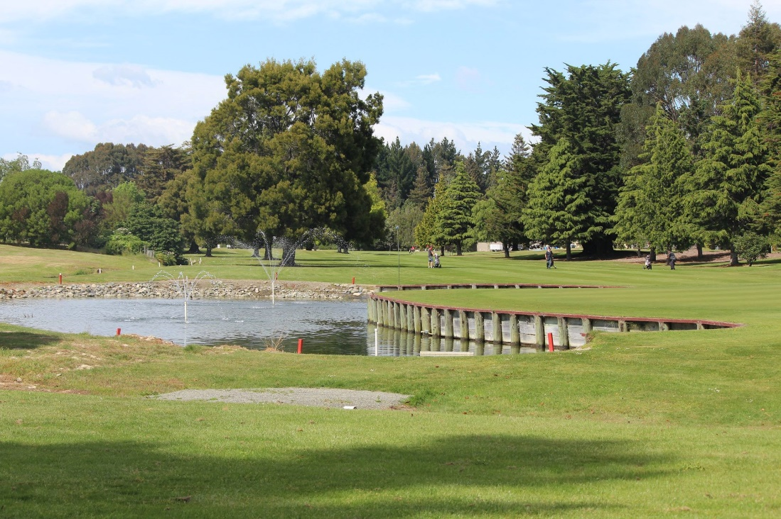

Gross, Net and Stableford competition over 36 holes

Graded divisions

Entry includes; Hole in One, BBQ, Club Team event (4 players, best 3 nets)

Nearest the Pin and Twos

**All-inclusive entry of just $30**

**To avoid disappointment, enter by; 1st March**

Email [andrew.maureen@xtra.co.nz](mailto:andrew.maureen@xtra.co.nz)

Andrew: Phone 03 544 4251 or 021 296 5699 (text)

or

Craig: Phone 027 241 8922 (text)

Provide name______________________________________

Club ID and Index___________________________________

Require a meal yes/no Extra meal $15. ___ required